**Student Basic Information Table:**

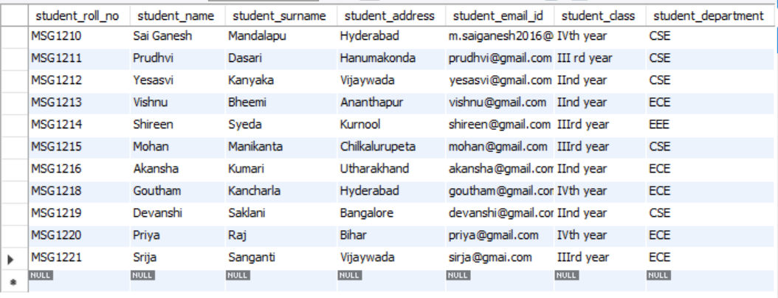

**Student Admission Details:**

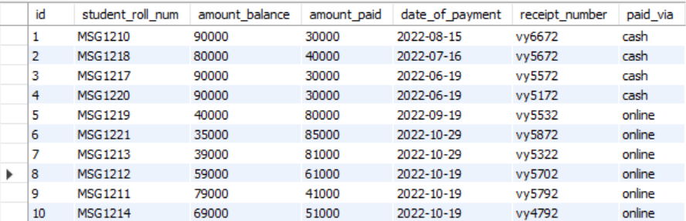

**Student Subject Information:**

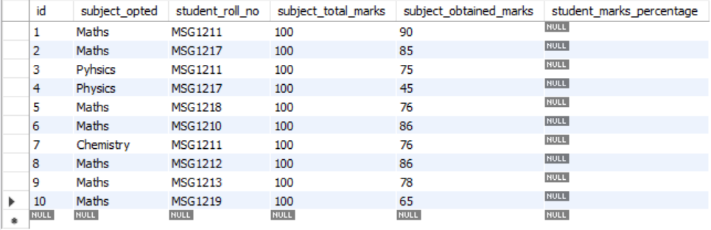

**Student Scholarship Information:**

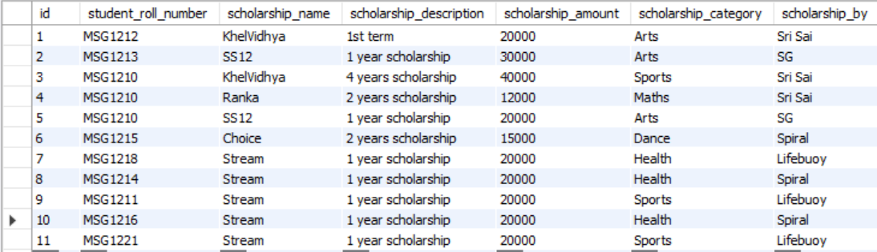

**5) Update any 5 entries**

UPDATE `student`.`student_scholarship_information` SET `scholarship_description` = '3 year scholarship' WHERE (`id` = '8');

UPDATE `student`.`student_scholarship_information` SET `scholarship_name` = 'SS12', `scholarship_description` = '2 year scholarship' WHERE (`id` = '9');

UPDATE `student`.`student_scholarship_information` SET `scholarship_description` = '1 year scholarship' WHERE (`id` = '1');

UPDATE `student`.`student_scholarship_information` SET `scholarship_by` = 'Sri Ganesh' WHERE (`id` = '3');

UPDATE `student`.`student_scholarship_information` SET `scholarship_name` = 'KhelVidhya' WHERE (`id` = '11');

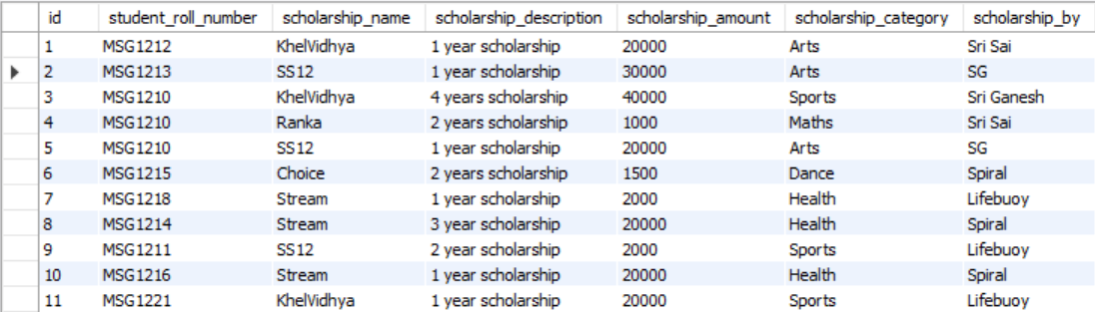

**7) Select the student details records who has received the scholarship more than 5000Rs**

select * from student.student_basic_information where student_basic_information.student_roll_no in (select student_roll_number from student.student_scholarship_information where student_scholarship_information.scholarship_amount>5000);

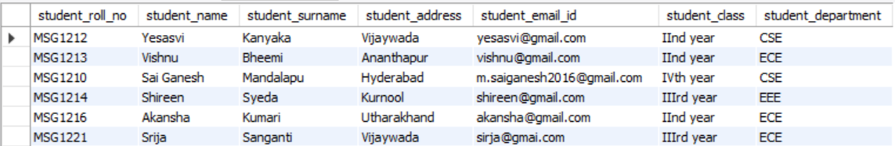

**8) Select the students who opted for scholarship but has not got the scholarship**

select student_roll_no,student_name from student.student_basic_information where student_roll_no not in (select student_roll_number from student.student_scholarship_information);

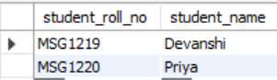

**9)** Fill in data for the percentage column i.e. StudentMarksPercentage in the table StudentSubjectInformation by creating and using the stored procedure created

DELIMITER $$

CREATE

PROCEDURE `student`.`mark_percentage`()

BEGIN

update student_subject_information set student_marks_percentage = (subject_obtained_marks/subject_total_marks)*100;

END $$

DELIMITER ;

Call mark_percentage();

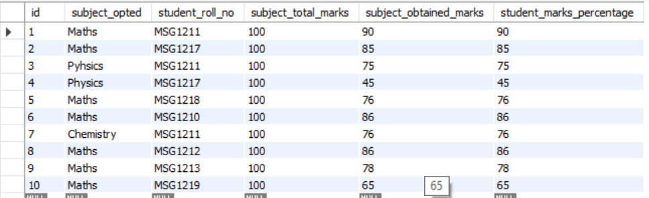

10) Decide the category of the scholarship depending upon the marks/percentage obtained by the student and likewise update the ScholarshipCategory column, create a stored procedure in order to handle this operation

DELIMITER $$

CREATE

PROCEDURE `student`.`set_category`()

BEGIN

update student_scholarship_information set scholarship_category= "Merrit" where student_roll_number in (select student_roll_no from student_subject_information where student_marks_percentage > 80 );

END $$

DELIMITER ;

Call set_category;

11) Create the View which shows balance amount to be paid by the student along with the student detailed information (use join)

create view `student`.`show_balance`

as

select student_roll_no, student_name, student_surname, student_address, student_email_id, student_class, student_department,amount_balance from student_basic_information join student_admission_payment_details on student_roll_no=student_roll_num;

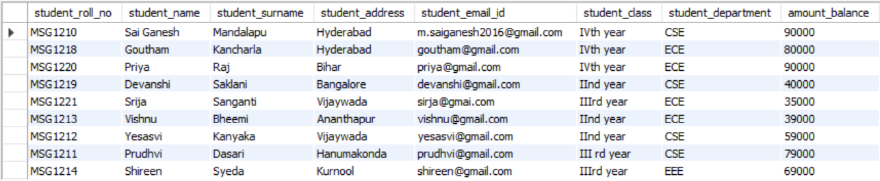

12) Get the details of the students who haven’t got any scholarship (use joins/subqueries)

SELECT student_roll_no,student_name FROM student.student_basic_information where student_roll_no not in (select student_roll_number from student.student_scholarship_information);

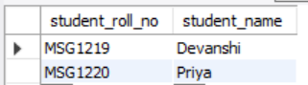

13) Create Stored Procedure which will be return the amount balance to be paid by the student as per the student roll number passed through the stored procedure as the input

DELIMITER $$

drop procedure if exists `student`.`balance`;

CREATE

Procedure

`student`.`balance` (in student_number varchar(40))

begin

select student_roll_no ,student_name,amount_balance from student_admission_payment_details join student_basic_information on student_roll_num=student_roll_no where student_roll_no=student_number;

end $$

DELIMITER ;

call balance("MSG1210");



14) Retrieve the top five student details as per the StudentMarksPercentage values (use subqueries)

select s.student_roll_no,s.student_name , d.student_marks_percentage from student.student_basic_information as s, student_subject_information as d where s.student_roll_no=d.student_roll_no and d.student_roll_no in (select k.student_roll_no from student.student_subject_information as k) order by d.student_marks_percentage desc limit 5;

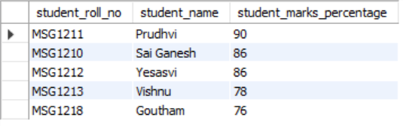

15) Try to use all the three types of join learned today in a relevant way, and explain the same why you thought of using that particular join for your selected scenarios (try to cover relevant and real time scenarios for all the three studied joins)

Scenario 1: *Students who have student_marks_percentage more than 60 but still not having any scholarship amount.*

select s.student_roll_no , d.scholarship_amount, s.student_marks_percentage from student_subject_information as s left outer join student_scholarship_information as d on s.student_roll_no=d.student_roll_number where s.student_marks_percentage>60;

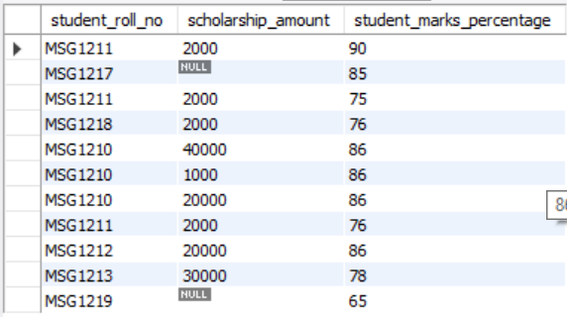

Scenario 2: *Students who have scholarship but not enough student marks percentage*

select s.student_roll_no , d.scholarship_amount, s.student_marks_percentage from student_scholarship_information as d right outer join student_subject_information as s on s.student_roll_no=d.student_roll_number where s.student_marks_percentage>60;

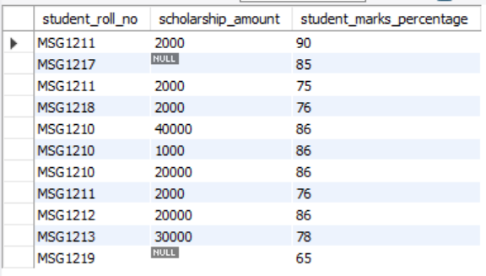

Scenario 3: Students who have both scholarship and marks percentage more than 60%

select s.student_roll_no , d.scholarship_amount, s.student_marks_percentage from student_scholarship_information as d inner join student_subject_information as s on s.student_roll_no=d.student_roll_number where s.student_marks_percentage>60;

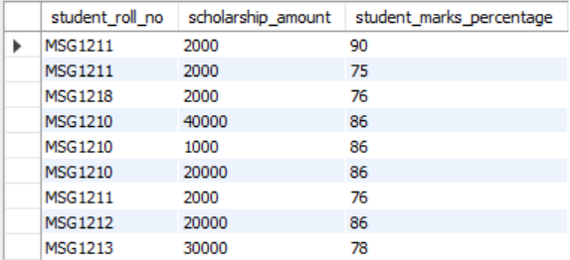

16) Mention the differences between the delete, drop and truncate commands

Drop and Truncate are DDL commands which change the entire structure of the table.

Truncate deletes all the records but not the structure of the table. It just removes all the data from the table.

Drop deletes all the data with the structure of the table. Data is completely lost and can’t be rolled back.

Delete can be used to remove the data with or without a condition or clause. Deletion of single or multiple rows depends on the query condition.

17) Get the count of the Scholarship category which is highly been availed by the students, i.e. get the count of the total number of students corresponding to the each scholarships category

select scholarship_category,count(student_roll_number) from student.student_scholarship_information group by scholarship_category order by count(student_roll_number) desc;

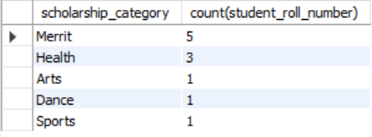

18) Along with the assignment no. 17 try to retrieve the maximum used scholarship category



19) Retrieve the percentage of the students along with students detailed information who has scored the highest percentage along with availing the maximum scholarship amount

select s.student_roll_no, s.student_name, s.student_email_id, sc.scholarship_amount, sub.student_marks_percentage from

student_basic_information as s join student_scholarship_information as sc join student_subject_information as sub on s.student_roll_no=sc.student_roll_number and sc.student_roll_number=sub.student_roll_no where student_marks_percentage in (select max(student_marks_percentage) from student_subject_information) and scholarship_amount in (select max(scholarship_amount) from student_subject_information);



20) Difference between the Triggers, Stored Procedures, Views and Functions

Trigger is invoked whenever an event occurs. They are programs which automatically get executed when some condition is met.

Stored procedure is a collection of statements that are stored inside a database. It has a name, parameters and set of statements that performs specific tasks.

View is a virtual table where data is not stored permanently. It is created for security purposes and for querying data by joining tables to save time.

Function is the same as a procedure, the only difference is that function can return value whereas a procedure cannot.